**New Summit College**

**Tribhuvan University**

**Certificate of Approval**

This is to certify that the project prepared by **Mr. Ganesh Neupane and Mr. Abhisekh Paudel, entitled** **“Student Assignment Management System*.*”** in partial fulfillment of the requirements for the degree of Bachelor of Computer Application has been well studied. In our opinion it is satisfactory in the scope and quality as a project for the required degree.

**Signature of the Supervisor Signature of the Academic Director**

...…….……….……………….. ..…..............….……….……….

**Mr. Dhurba Gynawali Mr. Chok Raj Dawadi**

Project Supervisor Academic Director

New Summit College New Summit College

Shantinagar, Kathmandu Shantinagar, Kathmandu

**Supervisor’s Recommendation**

I hereby recommend that the forthcoming project report prepared under my supervision by **Mr. Ganesh Neupane and Mr. Abhisekh Paudel** is satisfactory in the partial fulfillment of the requirement for the degree of Bachelor in Computer Application and be processed for the evaluation.

………………………………

**Mr. Dhurba Gynawali,**

Project Supervisor

BCA Department

New Summit College

Shantinagar, Kathmandu

**Acknowledgement**

It is a great pleasure to have the opportunity to extend our heartfelt gratitude to everyone who helped us throughout the course of this project. We are profoundly grateful to our supervisor **Mr. Prawesh Dhungana**, for his expert guidance, continuous encouragement and ever willingness to spare time from his otherwise busy schedule for the project’s progress reviews. His continuous inspiration has made us complete this project and achieve its target.

We would also like to express our deepest appreciation to **Mr. Chok Raj Dawadi,** Program Director of BCA and CSIT, New Summit College, for his constant motivation, support and for providing us with a suitable working environment.

We sincerely acknowledge direct and indirect help, suggestions and feedback offered by our colleagues before, during and after the development and implementation of the project.

At last our special thanks go to all staff members of BCA department at New Summit College who kindly extended their hands in making this project work a success.

# Abstract

Health has been a prime factor in the national development vortex of Nepal ever since this COVID-19 pandemic began. In almost every big talk about rights, opportunities, and growth, health comes as the top necessity. However, the situation has not taken a big leap, even though we have seen signs of improvements and amendments over the years in the Health sector. Traditionally, hospitals work majorly on a pen-and-paper basis. In this paper, we consider a system to regulate the vast amount of data inside a hospital through digitization and computerization of the past and future data. From a user (patient/hospital) perspective, future access to information is critical, which is difficult with the current manual model. We asked, “What if the medical ticket provided by the hospital is lost? Is there an effective way which can regulate the patient information and store it for future use?” To make sure patient data are easily available for future references, we create a database of all patient records and allow them to be cross-referenced. We build a basic platform (a web application) for facilitating patient with medicines delivery at their doorstep and booking appointments staying at their place without the hassle of being in a queue crowd. The patient will get prescriptions and suggestions from specialists/ doctors. The patient will get reminder notifications for medicines and follow-ups. This allows us to use the database to serve as the back-end of our application. We find via testing and user feedback that our system is efficient and effective in the automation of the hospital system.

Keywords: Herchaha, Hospital, Book Appointments, Prescription

**Table of Contents**

Abstract ii

Introduction 1

1.1 Background 1

1.2 Problem Definition 1

1.3 Objectives 2

1.4 Limitations 2

Requirement Analysis and Feasibility Analysis 3

2.1 Literature Review 3

2.2 Proposed System 3

2.4 Advantage of Proposed System 4

2.5 Requirement Identification 4

2.5.1 Functional Requirements 5

2.5.2 Non-Functional Requirements 8

2.6 Feasibility Analysis 9

2.6.1 Technical Feasibility 9

2.6.2 Operational Feasibility 9

2.6.3 Economic Feasibility 9

2.6.4 Schedule Feasibility 9

System Design 10

3.1 System Design 10

3.2 System Architecture 11

Implementation 12

4.1 Methodology 12

4.1.1 Tools Used 13

Conclusion 14

5.1 Expected Outcomes 14

Reference 14

**CHAPTER 1**

# Introduction

## 1.1 Background

While today is a time of growth, it is also a time of growing pains. In the current scenario in Nepal, Increasing health care demands is a serious phenomenon. An emergency health care demand in Nepal is an unprecedented increment to provide an effective health care service. And for the use of and access to Information and Communication Technology in minimizing this problem and providing an effective health care service staying at your home, the figures that stand are negligible.

Herchaha is a healthcare platform that connects patients with the hospital (A web-based application). It is designed specifically for the patients with hectic schedules and difficulties in standing in a queue crowd. The details, the medical history, diagnosis results, and records are stored in a secure database. Based on the details, Herchaha provides the patient with the facilities of booking appointments staying at their place. At the same time, Herchaha provides the patients with facilities of prescriptions and suggestions by doctors.

## 1.2 Problem Definition

Health is a fundamental right for all, and there cannot be any negotiation. In Nepal, there have rarely been ample discussions and contributions towards digitizing the health care services. In the current model of Nepal's health care services, various problems are present, viz.

* Staying in a queue crowd to book an appointment.
* Sale of unverified medicines and without proper dosage that led to pose health risks.
* Customers' hassle of paying bills.

## 1.3 Objectives

The objectives of the project are:

* To develop a system that allows users to book appointments.
* To develop a system that allows users to get prescriptions.
* To develop a system that allows users to pay bills.

## 1.4 Limitations

* The target platform initially is a web-based application.
* The system design of this project only supports specific hospital.

**1.5 Report Organization**

This report is organized into 5 chapters:

* ***Chapter 1: “Introduction”-*** This chapter introduces the problem statement, objectives and limitations of the project
* ***Chapter 2: “Requirement and Feasibility Analysis”****-*This chapter describes about the functional and non-functional requirements, economic feasibility, technical feasibility, operational feasibility and scheduling feasibility.
* ***Chapter 3: “System Design”***-This chapter introduces about the system and interface design of the project app.
* ***Chapter 4: “Implementation and Testing-*** This chapter clearly illustrates the methods and tools used to implement the project
* ***Chapter 5: “Conclusion and Future Works”-*** This is the final chapter that concludes the project and talks about our future plans with the project

**Chapter 2**

# Requirement Analysis and Feasibility Analysis

## Literature Review

**Merohealthcare**

The online pharmacy by Suraj KC provides digital healthcare services such as booking appointments, medicines delivery, and lab services.

If a patient were to decide to buy medicine for the next time, the system requires uploading the prescription. Meanwhile, the manual paper system is bound to fail because of the inevitability of patients losing the medical tickets provided by hospitals. The previously gathered data would have to be collected again. The system is focused more on commercialization than ease of access for all parties involved. The system sells some products without a prescription, which can be allergic to a person.

## 2.2 Proposed System

* In this project, we propose a system for booking appointments, and providing prescriptions and suggestions via an organized portal.
* The system will contain a web application and the backend (PHP).
* The system will contain three major modules- the patient, the doctor and the admin. Each system user will be able to use exactly one of these modules based on their position.
* Each system user will have unique credentials to log in to the system and gain the privileges associated with their user-type.
* The privileges associated with user types:
  + - **Patients:** Make appointments with doctor, check his/her entire medical history, and Pay bills.
    - **Doctors:** View the appointments, access the patient data, approve the appointments, and provide prescriptions.
    - **Admin:** Manage the doctors, view the doctors list, view the patients list, view prescriptions, and view the appointments details.

## 2.4 Advantage of Proposed System

* Our solution to the problem is to replace the manual method with computerization, which guarantees long-term storage and ease of access.
* A Hospital has the benefit of not wasting much time collecting history because the patient's profile will have a detailed history of the patient.
* No professional training or expertise is required for operation.
* Digitalization of large amounts of data for easy and remote access.

## 2.5 Requirement Identification

At the beginning of every project, and especially ones with a social cause, should never be assumed of feasibility and viability beforehand. This was realized and therefore, before starting on working on the project, the requirements of this project have been listed. Below are the basic functional and non-functional aspects of our requirements listed:

### 2.5.1 Functional Requirements

* **Login**

Users can log in using the unique credentials provided by the system admin.

* **Book Appointment**

Patients can make appointments with doctors who can be filtered by system admin.

* **View Appointment**

Doctors can view the appointments for the day, and request to access the patient data.

* **User Profile**

Create or update a patient record after the appointment as well as create prescriptions which will be updated in the patient profile.

* **Doctor-Patient Info**

Treatment history of each patient with their specific doctors.

* **Doctors List**

Patients can view the list of all available doctors.

* **Patient List**

Hospital can view a list of registered patients.

* **Admin control**

Admin panel is for the insertion, deletion, and updating of the users if any problem arises.

**2.5.2 Use Case Diagram:**

### 

### 2.5.3 Non-Functional Requirements

* **Usability**

The system should be user friendly. The UI should be intuitive and require no training for use.

* **Response time**

The typical response time between the click and the reaction will be less than 0.5 seconds, which is considered ideal.

* **Required resources**

Users will only require one smart device, each with more than 2GB of RAM.

* **Platform**

Right now, the target platform initially is web-based. But as time passes, the system will be built as a cross-platform version of the product (preferably in Mobile based app).

* **Maintainability**

The product will be coded and maintained in PHP.

## 2.6 Feasibility Analysis

### 2.6.1 Technical Feasibility

To implement this idea is a fairly simple thing. The technical aspects of this project will require following components, which are in today’s time easy and highly convenient to assemble:

* Smart phones/smart devices for users (Android/ IOS)
* PC for system admin

### 2.6.2 Operational Feasibility

Herchaha is a web app; it has a genuinely simplistic user interface where all the users need to do is login and uses the icons to navigate through the app. It does not have any legal issues. It is developed simply to make a task easy for hospital and patients, which does not require any external approval.

### 2.6.3 Economic Feasibility

This application cost is moderate. Therefore, there is no issue with usability. The tools and technologies used in this project are easily available, which does not lead to any economic hurdles, and can be developed easily.

### 2.6.4 Schedule Feasibility

Since the project is a basic hospital management tool, the project timetable won’t take too long to be implemented at all. Project will be scheduled on a weekly basis, with the internal deadlines including each component to be developed and parsed timely. All in all, the idea has been scheduled to be implemented within 1 month.

**CHAPTER 3**

# System design

## 3.1 System Design

Herchaha comes with a simple user interface for digitizing online healthcare services. This app has been designed **using php language**.

Firstly, the user is presented with a login screen.

Suppose the user enters the correct username and password. Now this works in following steps:

a) The user is logged in.

b) The user can navigate using the navigation bar.

And it goes on for all the users.

Navigate

Interact

Login

**Fig 3.1:** Working Methodology of Herchaha

## 

## \3.2 System Architecture

**Client (Patients)** **Client (Hospital)**

**Tasks:** **Tasks:**

* 1. Login 1. Login
  2. Make appointments 2. View appointments
  3. Order medicine 3. Request for history
  4. View notifications 4. Create/update records
  5. Doctor info 5. Create prescriptions

**Server**

**Tasks:**

Validate login

Update database

Send approval requests

Verify approval responses

**Fig 3.2**: System Architecture of Herchaha

**3.3** **Sequence Diagram**

**3.3.1 Sequence Diagram of Patient**

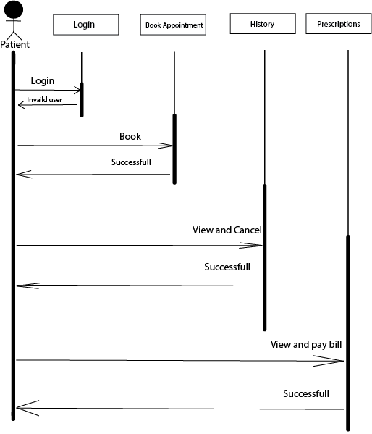

Fig 3.3.1 Sequence diagram of Patient

**3.3.2 Sequence Diagram of Doctor**

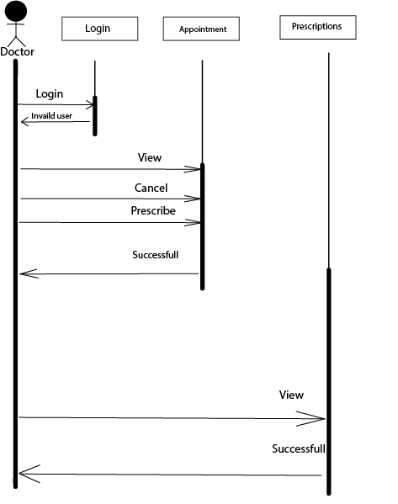

**Fig 3.3.2:** Sequence diagram of Doctor

**3.3.3 Sequence Diagram of Admin**

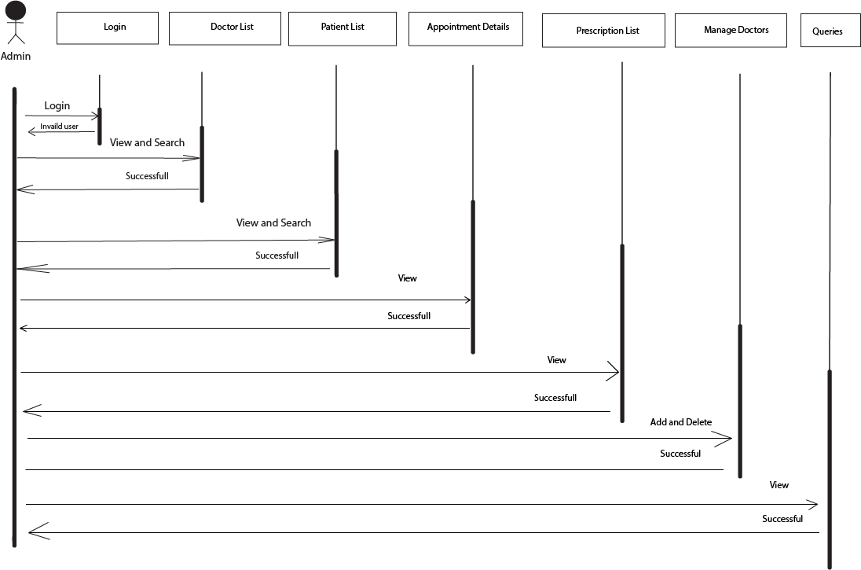

**Fig 3.3.3**: Sequence diagram of Admin

**CHAPTER 4**

# Implementation and Testing

## 4.1 Methodology

**Scrum Framework- Agile Model**

As the core tenets of Agile Model include addressing the needs of customers and embracing change, we have used Scrum rules and elements to guide this project and lead to a successful conclusion. Each team establishes an iterative cycle to improve outcomes and the value to patients, to the hospital team, and to the overall system.

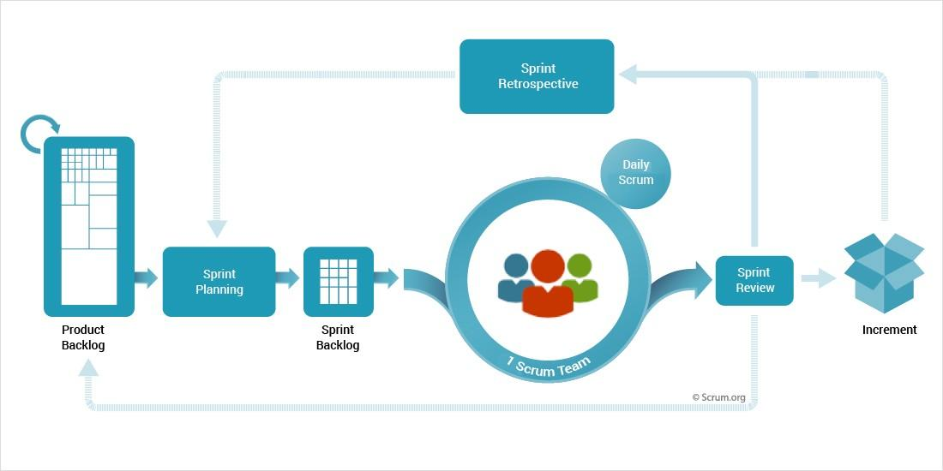

**Fig4.1**: Scrum Framework- Agile Model

### 4.1.1 Tools Used

* **HTML, CSS and JS**

HTML, CSS and JS were used to create the web application.

* **PHP**

PHP is used for back-end development.

* **Database**

MYSQL is used for databases.

* **Visual Studio Code**

Visual Studio Code is used as Integrated Development Environment for source code editing, build automations & debugging Herchaha web application.

**4.2 Testing**

Testing is done in each and every project during or after the completion of building the product. As the project is using an agile model as the software development model, the modules have been kept on testing in each sprint. So, far the unit testing of the modules has been done iteratively to find if they work properly or not (abcd, 2017).

**4.2.1 Unit Testing**

The Unit testing part of a testing methodology is the testing of individual software modules or components that make up an application or system. These tests are usually written by the developers of the module and in a test-driven-development methodology they are actually written before the module is created as part of the specification. As work was divided and after coding it was tested in parallel and after getting bugs it was made bug free. Completing module & testing was done together.

|  |  |  |  |  |
| --- | --- | --- | --- | --- |
| S.No. | Test Objective | Test Conditions | Expected results | Outputs |
|  | User Registration | Registration and Submission | Registration successful | Success |
|  | Users Login | Check login | Login successful to go to dashboard. | Success |
|  | Add doctor | Add the doctor by admin. | Doctor should be added. | Success |
|  | Delete doctor | Delete the doctor by admin. | Doctor should be deleted. | Success |
|  | Book appointments | Book an appointment by patient. | Appointments should be booked. | Success |
|  | Prescription | Prescription for patients from doctor. | Prescription should be given. | Success |
|  | Logout | Click Logout | Redirect to login page | Success |

**4.2.2 System Testing**

The system testing part of a testing methodology involves testing the entire system for errors and bugs. This test is carried out by interfacing the software components of the entire system, and then testing it as a whole. This testing is listed under the black-box testing method, where the software is checked for user expected working conditions as well as potential exception and edge conditions.

**CHAPTER 5**

# Conclusion and Future work

## 5.1 Conclusion

At the end of our project, we expect to have a system consisting of a web application and a backend to regulate, add/delete, and prescriptions via an organized portal. We would have created a system will consist of three major modules- Patients, doctor and admin. Each system user will be able to use exactly one of these modules based on their position. The system user will have unique credentials to log in to the system and gain the privileges associated with their user-type.

With our system, we significantly improve the communication pipeline between the admins, patients and associated hospitals. The patients will be able to book an appointment staying at their place. Once the patient enters the system, he wouldn't have any hassle of staying in the queue crowd to book appointments and to pay bills.

**5.2** **Future Work**

The amount of hard work that has been put into this project will be the root for the fact that the project will not end at what has been achieved so far. Herchaha will further be extended with more features and benchmarks in the future as a smart hospital management system. The future work will include:

* The current system is limited to web based applications. In the future, the system will be adhered to mobile based applications which will allow users to set preferences based on their interest.
* The current system is limited to booking appointments. The future work out will be adding the facility of ordering medicine and notifying the patients to take medicine and visit for follow ups.

**APPENDIX (I)**

**SCREENSHOTS**

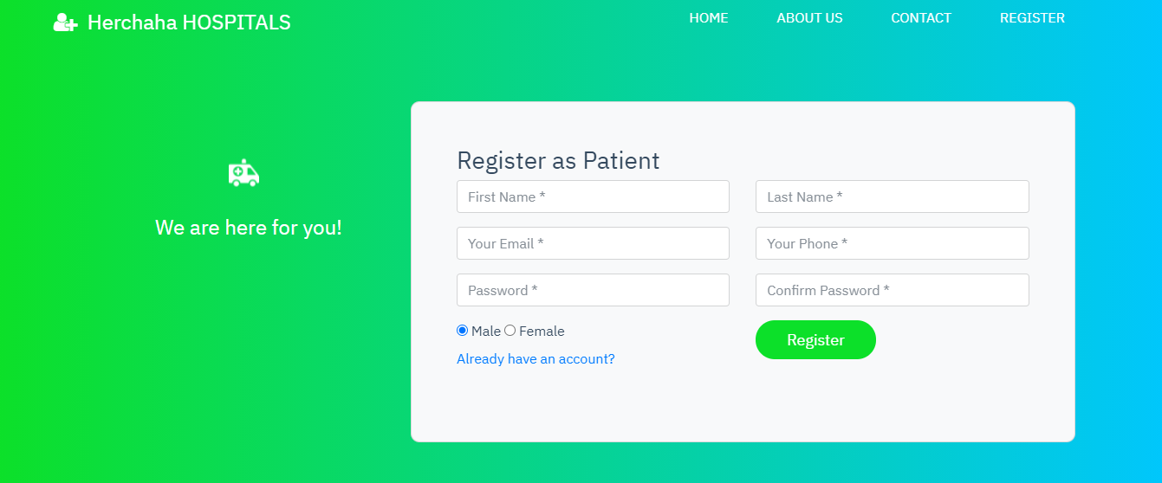

Patients Register

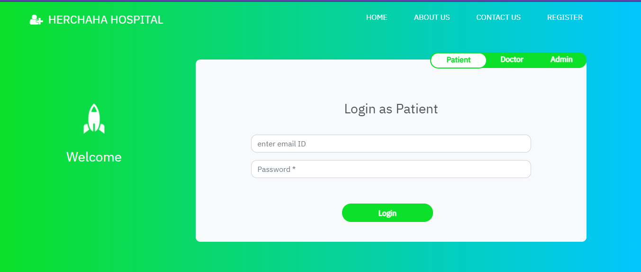

Home page (Patient Login)

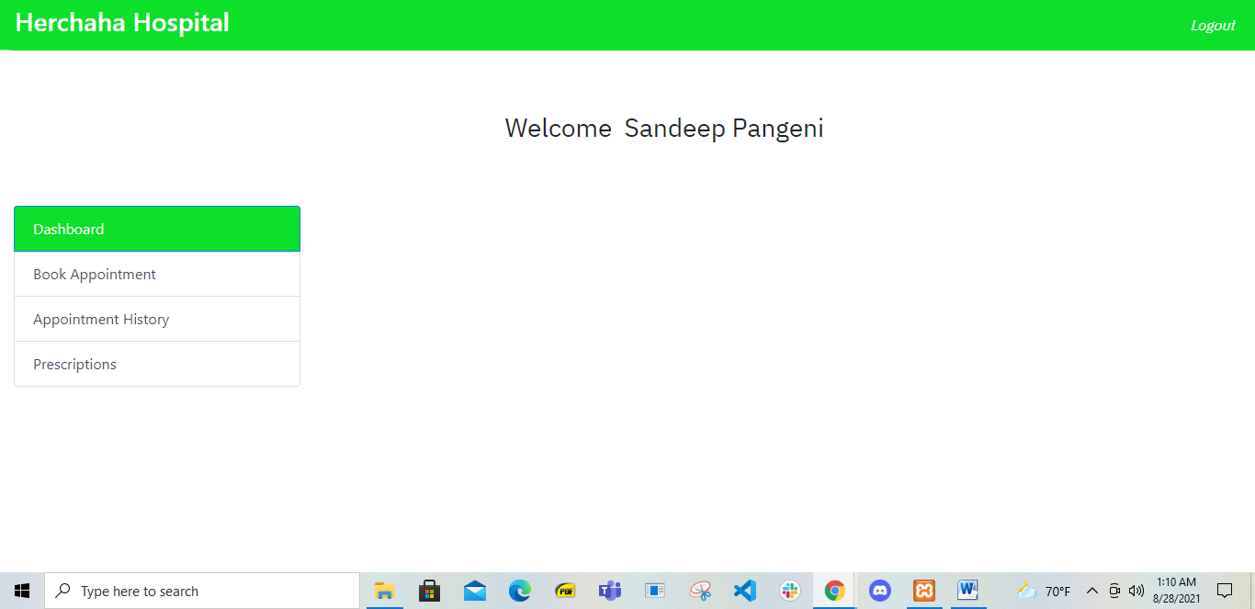

Fig Patient Dashboard